

Internal Memorandum

To: Paula Alexander <hal.cio@seccdc.org>

CC: judge_29@seccdc.org

From: hal29@seccdc.org

Date: February 23, 2019

Memo #: 004

Re: Malware Scan

Greetings CIO,

As per your request, our team has downloaded and installed antivirus software on all of our systems. For our Windows systems, we have chosen to use Malwarebytes and Windows Defender and for our Linux systems ClamAV was our choice. A malware scan was performed on all systems and some potentially malicious items were found the Server 2008R2 system which have been quarantined pending further investigation by our team. In accordance with HAL company policy an incident response form will be completed for all identified threats. Below are screenshots showing the completed scans for each system.

Phantom:

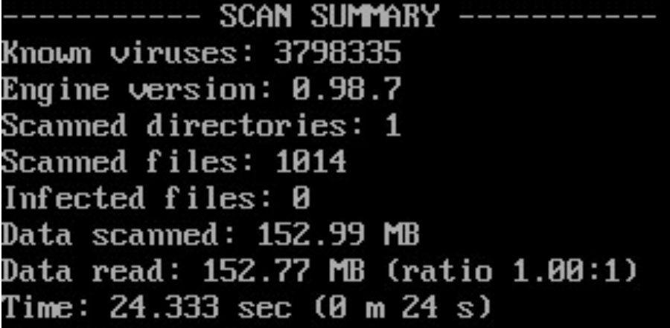

Debian 7.8:

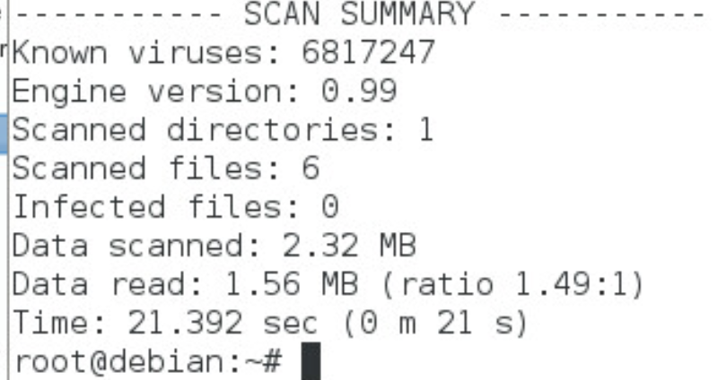

Ubuntu 12.04:

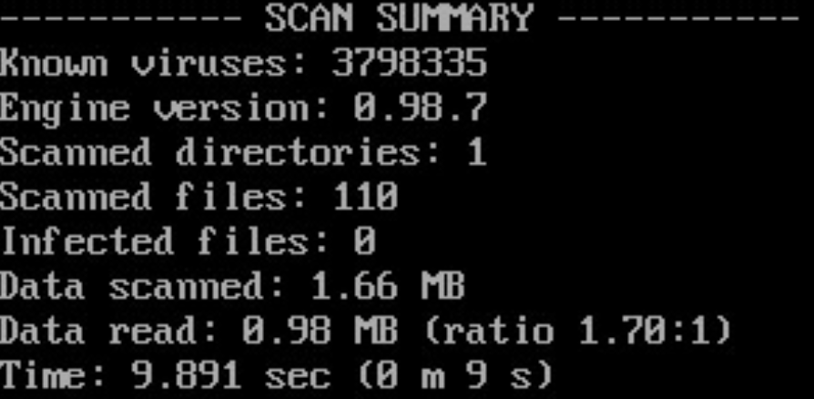

Windows Server 2008R2: 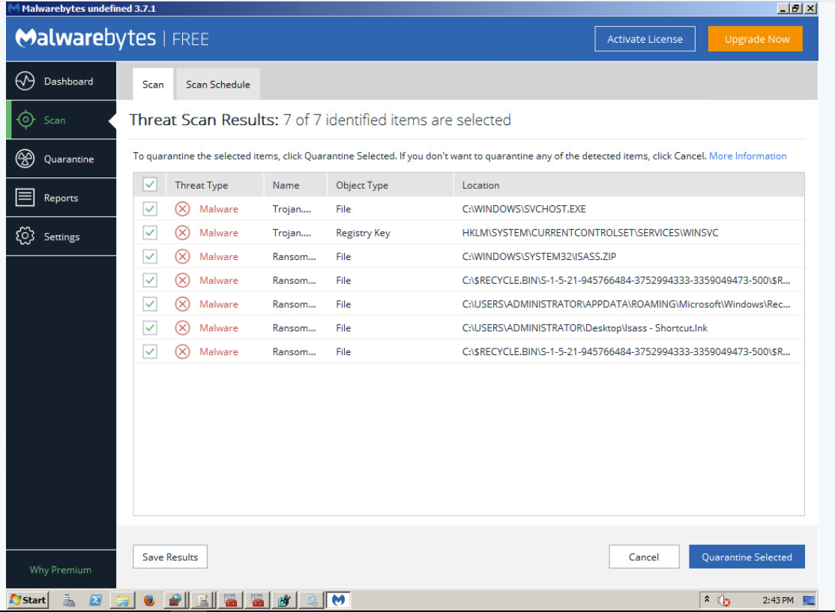

Windows 8.1:

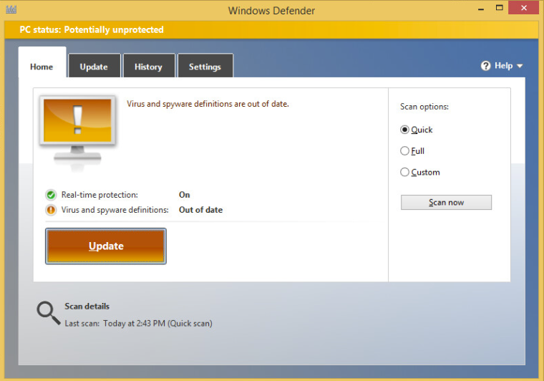

Splunk:

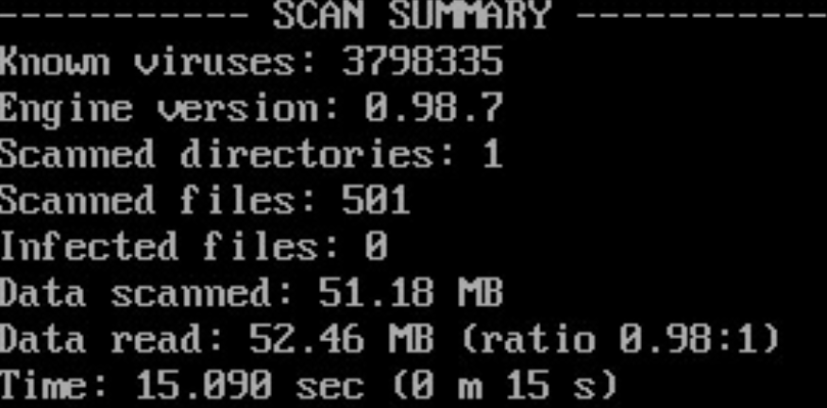

CentOS 6.0:

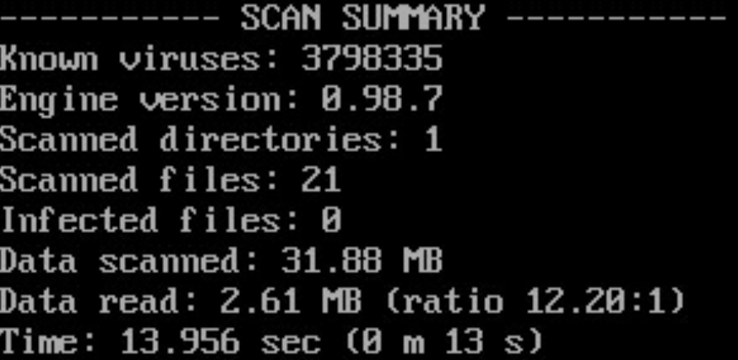

Fedora 21:

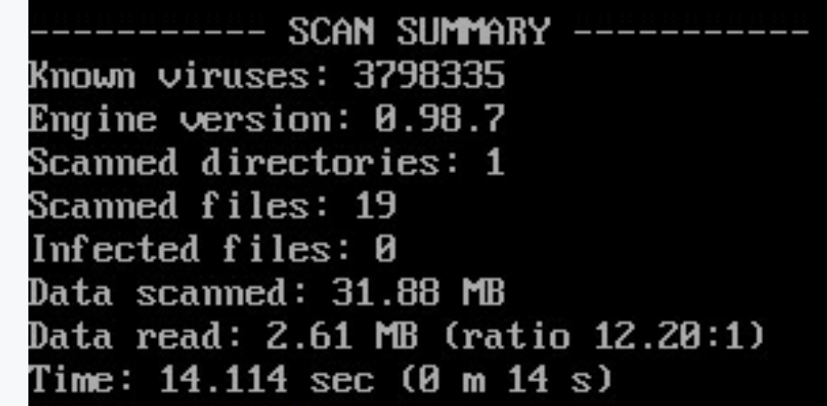

Windows 10:

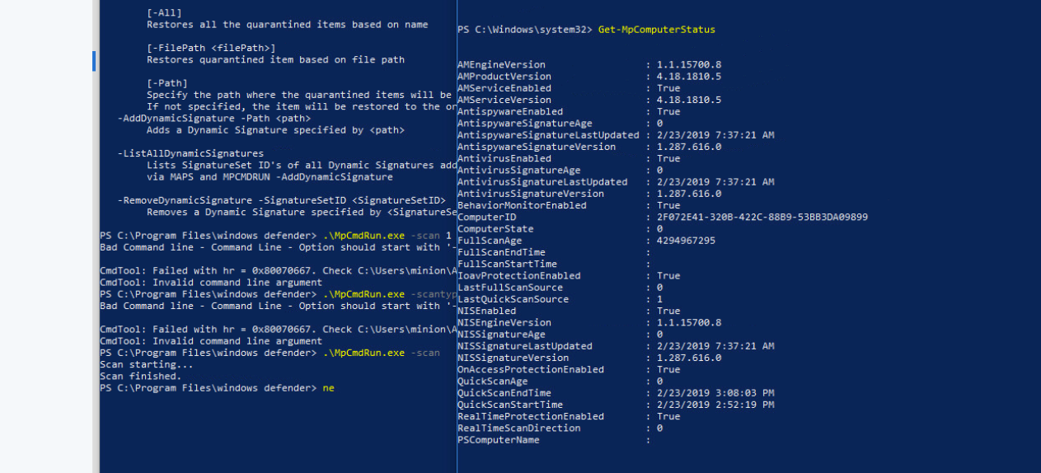

Regards,

Team 9

*In accordance with HAL Memorandum policy, the entire header must be completed or the recipient may not acknowledge this as an official memorandum. Professional communications methods and decorum must be observed at all times.*